PSK m file practice

fm_fc_time=4

ca=sin(2*pi*fc*t)

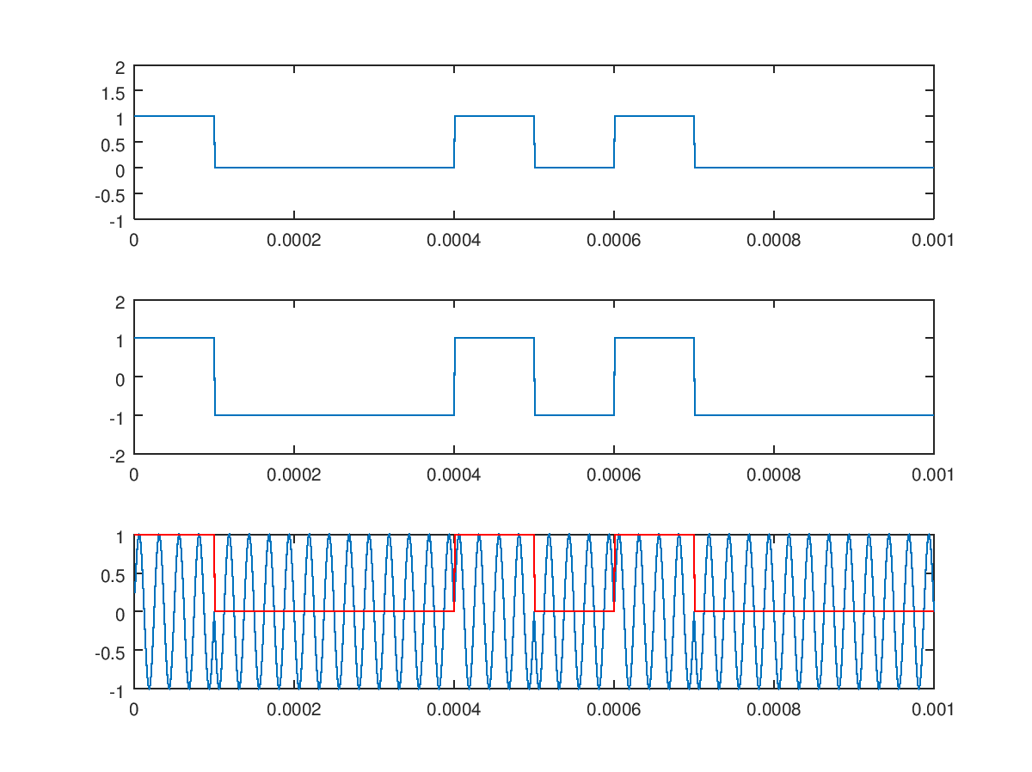

fm_fc_time=4

ca=cos(2*pi*fc*t)

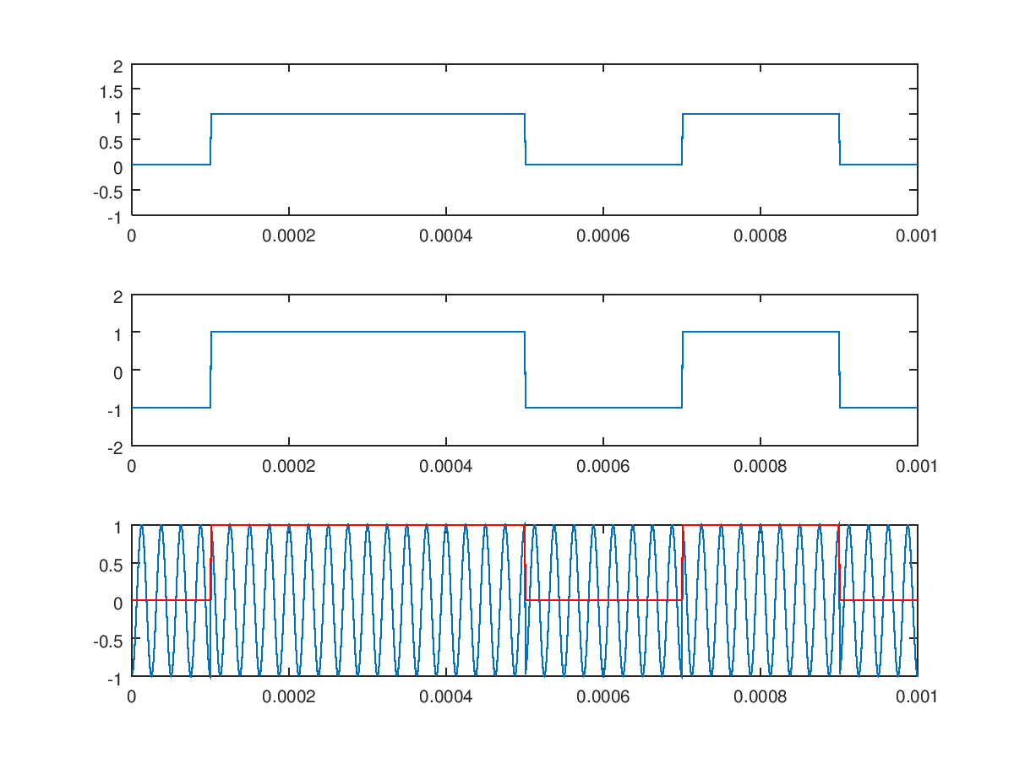

fm_fc_time=2

ca=sin(2*pi*fc*t)

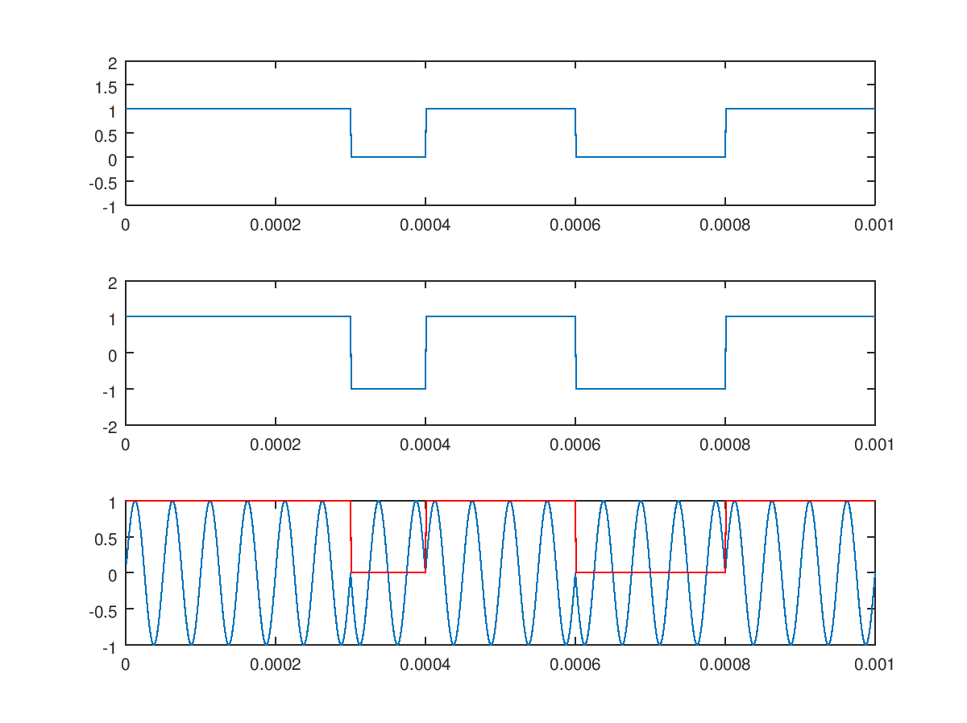

fm_fc_time=2

ca=cos(2*pi*fc*t)

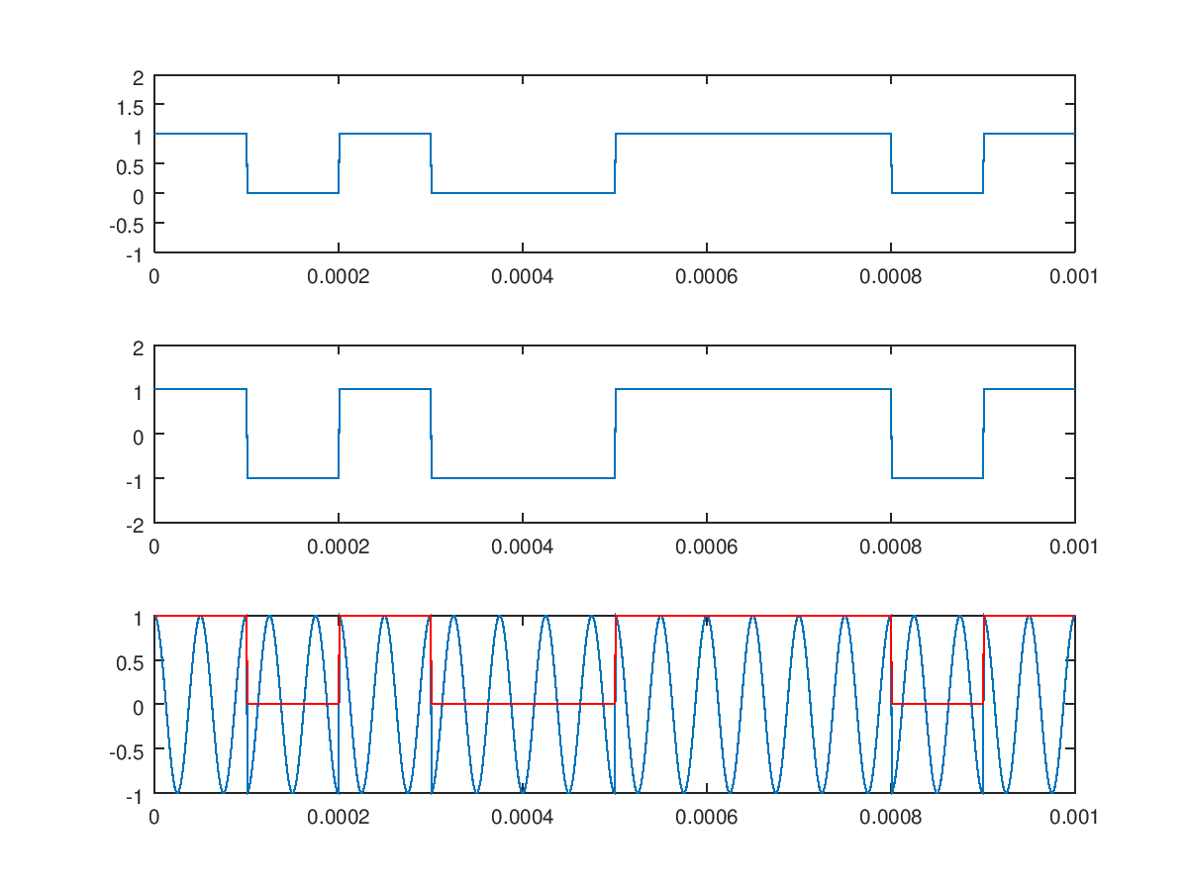

% CH05_07

% Phase Shift Keying (PSK)

clear all;

close all;

fm=10^4;

fm_fc_time=2;%方坡內載波

fc=fm_fc_time*fm;

delta_f=2;

num_bit=10;

resol_index=100;

t_step=1/(resol_index*fm);

t=t_step:t_step:num_bit*(1/fm);

bit_stream=round(rand(1,num_bit));

ca=cos(2*pi*fc*t);%sin跟cos

linecode=bit_stream'*ones(1,1/(fm*t_step));

linecode_res=[];

for i=1:num_bit

linecode_res=[linecode_res linecode(i,:)];

end

bip_linecode=linecode_res*2-1;

v=ca.*bip_linecode;

subplot(3,1,1);

plot(t,linecode_res);

ylim([-1 2]);

subplot(3,1,2);

plot(t,bip_linecode);

ylim([-2 2]);

subplot(3,1,3);

plot(t,v)

hold on;

plot(t,linecode_res,'r')